**B.Tech(ECE)-QUANTUM UNIVERSITY-1-Task4-** **Take the same scenario as a reference  
 Now, use any online design thinking tool to prepare a customer journey  
map for the given example**

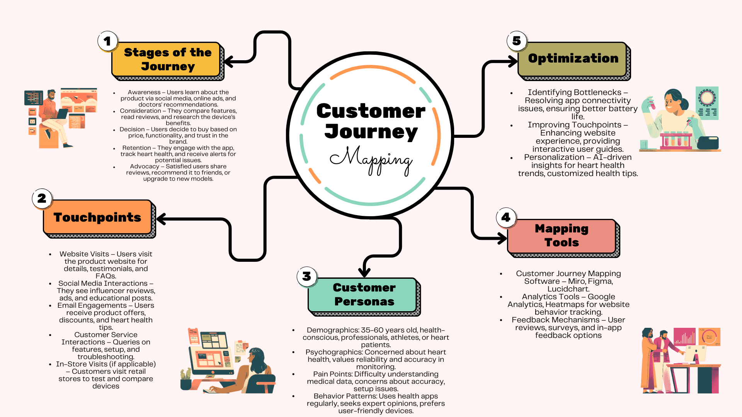

**Overview of Customer Journey Mapping for Heart Rate Monitoring Device**

The **customer journey** for a **heart rate monitoring device** follows a structured flow from initial awareness to advocacy. Users typically become aware of the product through **advertisements, doctor recommendations, or social media**. In the **consideration phase**, they research features, compare with competitors, and look for customer reviews.

Once they **decide to purchase**, they interact with various **touchpoints** such as websites, in-store visits, or customer support. Post-purchase, users engage with the device, track their heart rate, and use app-based analytics to monitor health trends. If satisfied, they move into the **retention and advocacy phase**, sharing positive reviews and recommending it to others.

To **optimize the experience**, companies need to enhance **customer support, improve user onboarding, and personalize health insights**. Using **analytics and customer feedback**, they can address pain points like **battery life, accuracy concerns, and complex setups** to ensure better engagement and long-term customer satisfaction.

Would you like a **detailed visual map** for this?